**SYST17796 Deliverable 3**

Updated UML Diagram

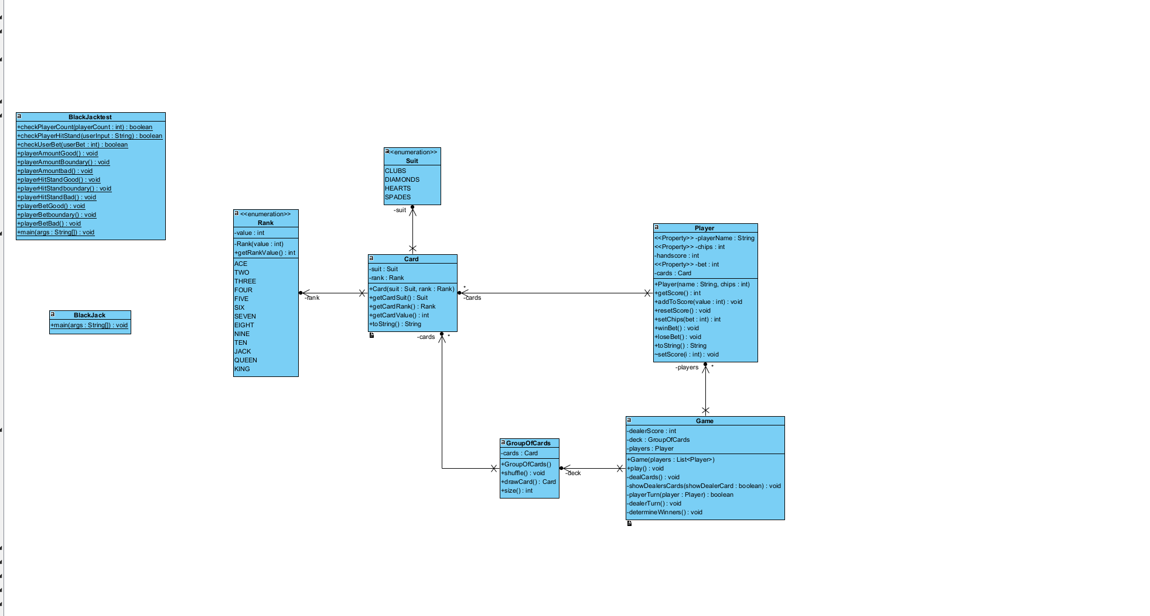

Github References

<https://github.com/HuntSean17/SYST17796-Group-7-Final-Project>

Contains the project starter code, the final version called blackjack and the VPP files in the text files folder with the JUNIT tests in the blackjack folder as shown in the UML.

Test Results Report

| Requirement | Use case | Test method | Status date |
| --- | --- | --- | --- |
| User bet works as intended | Regular play | blackJackTest.checkUserBet | Passed  07-04-2024 |
| Player count only takes 1-4 players | Regular play | blackJackTest.checkPlayerCount | Passed  07-04-2024 |
| Players can hit or stand | Regular play | blackJack Test.checkPlayerHitStand | Passed  07-04-2024 |